Section B: Practical Task

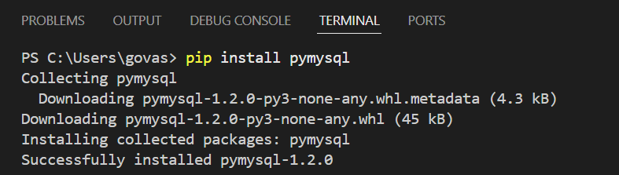
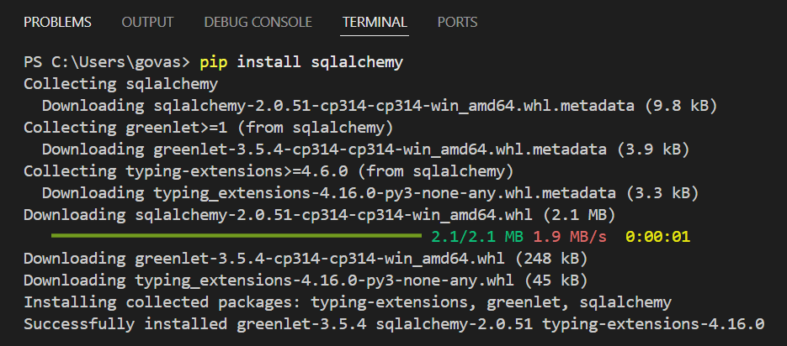
Python-based ETL Script using SQLAlchemy :

QUESTION : 1
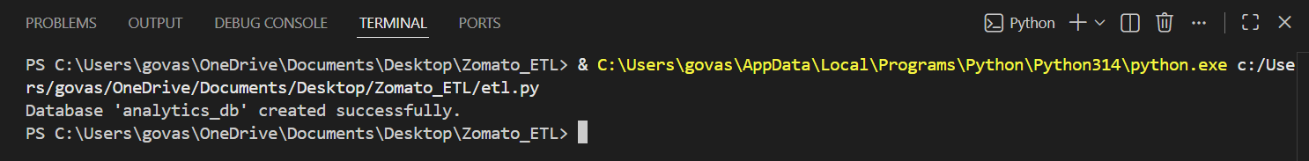
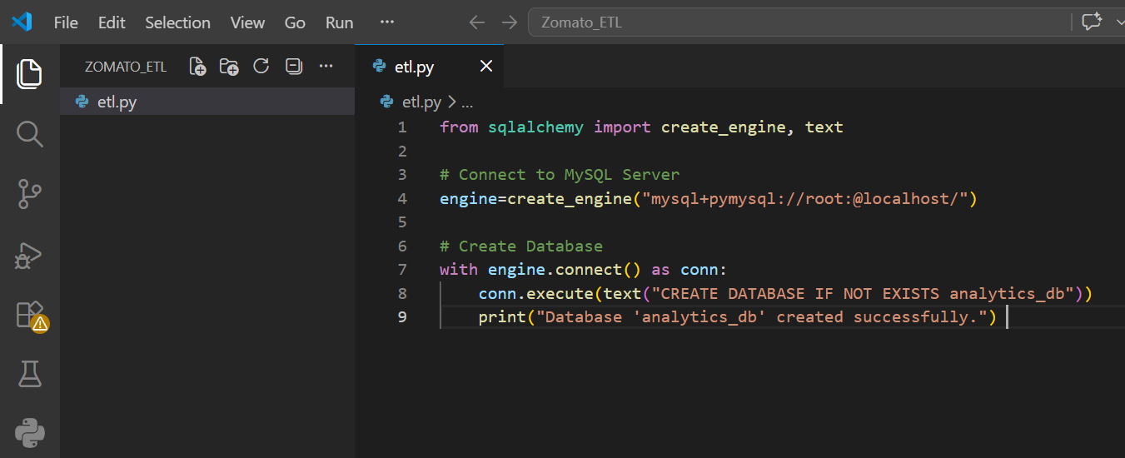
Develop a Python-based ETL script using SQLAlchemy to automate the creation of the analytics_db schema and enforce composite primary keys on the ratings table :
Analytics_db in phpMyAdmin…
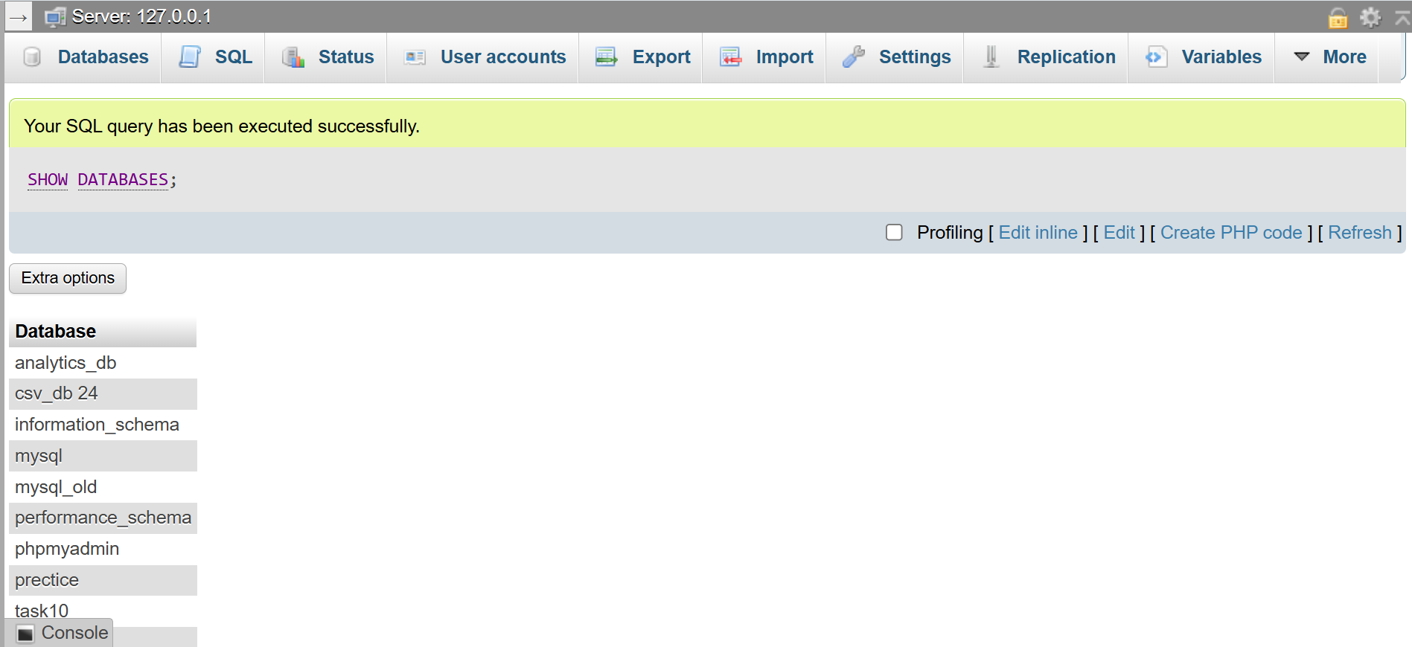
Explanation :
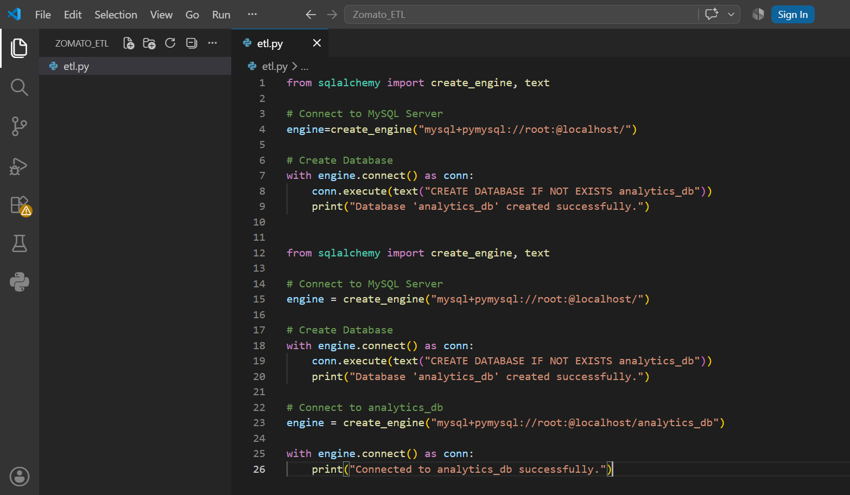
“ This Python ETL script uses SQLAlchemy to connect to the MySQL server and automatically creates the analytics_db database if it does not already exist. This automates the database setup process for the Zomato analytics project ”
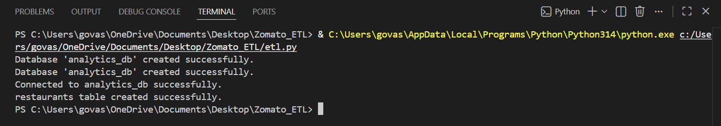
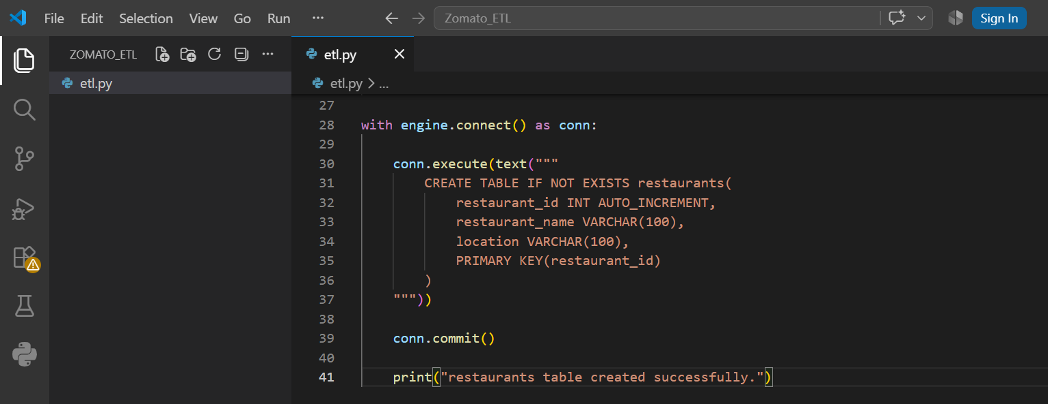
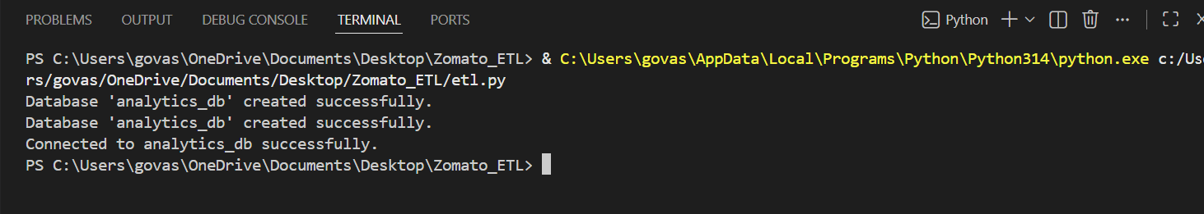
Explanation :
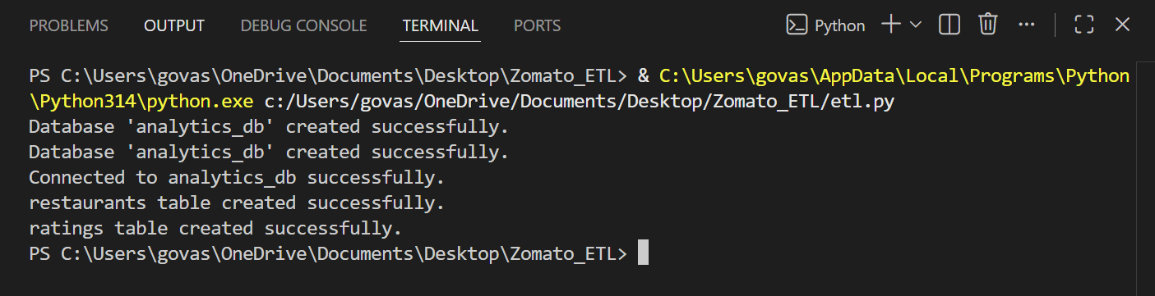
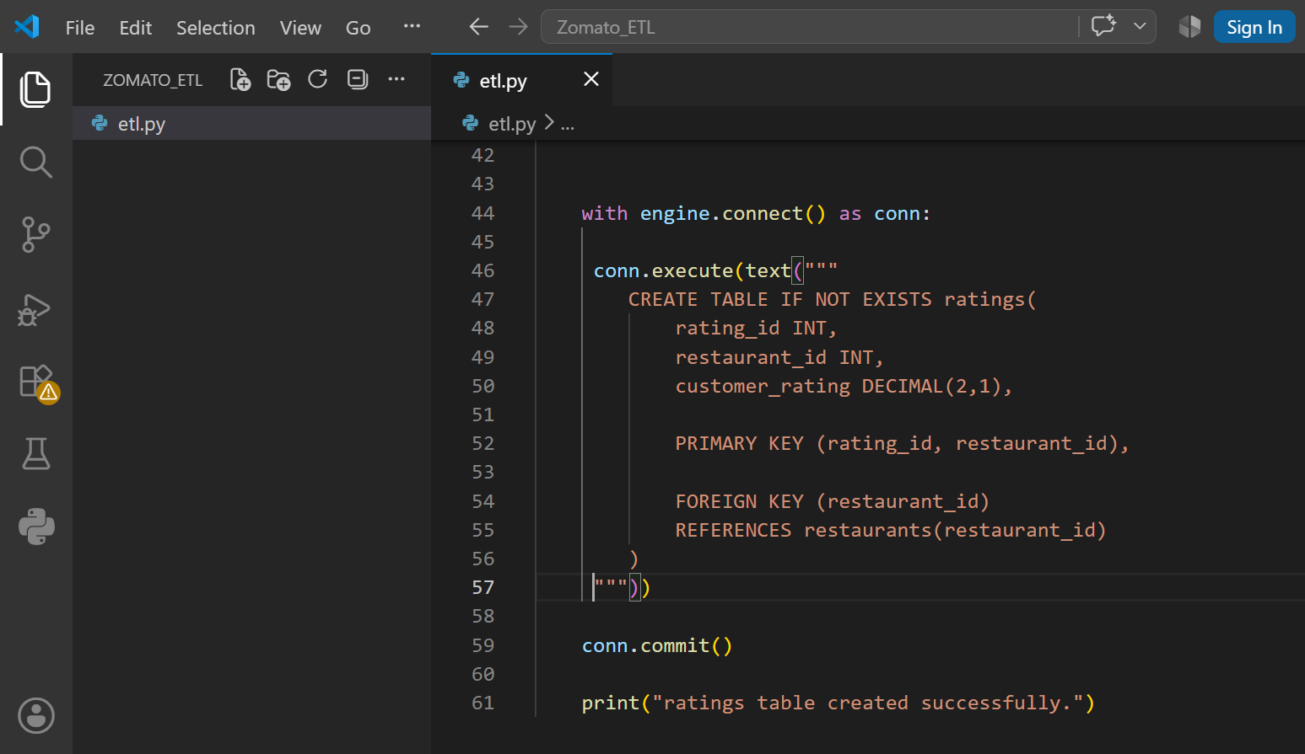
“ The ETL script connects to the analytics_db database using SQLAlchemy and automatically creates the restaurants table. Automating table creation reduces manual work and ensures a consistent database structure ”

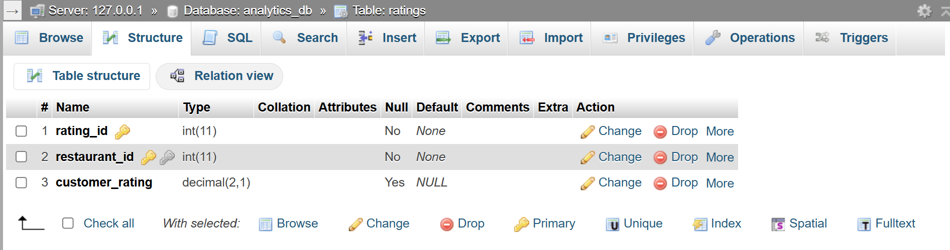
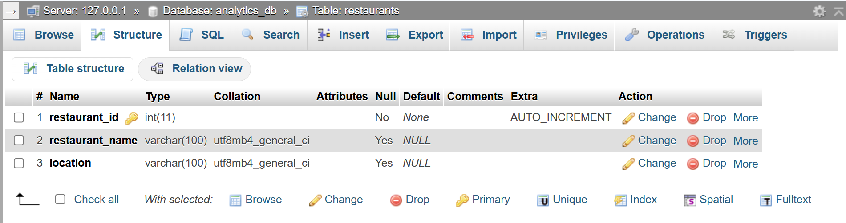
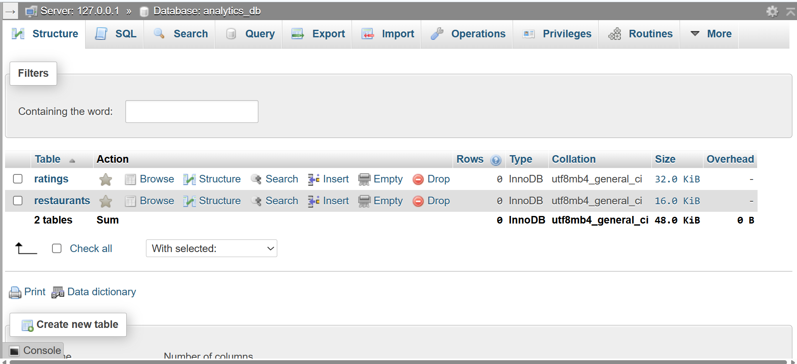

Explanation :
“ The ETL script uses SQLAlchemy to automatically create the restaurants and ratings tables. The ratings table uses a composite primary key consisting of rating_id and restaurant_id, ensuring that each rating record is uniquely identified while maintaining relational integrity ”

Referential Integrity using ALTER TABLE :

QUESTION : 2
Implement SQL ALTER statements to establish Referential Integrity through Foreign Key constraints between restaurants and locations with ON DELETE CASCADE actions :

TABLE locations :
CREATE TABLE locations(
location_id INT AUTO_INCREMENT PRIMARY KEY,
location_name VARCHAR(100)
) ;

INSERT INTO locations (location_name)
VALUES ('Koramangala'),('Indiranagar'),
('Whitefield'),('MG Road') ;

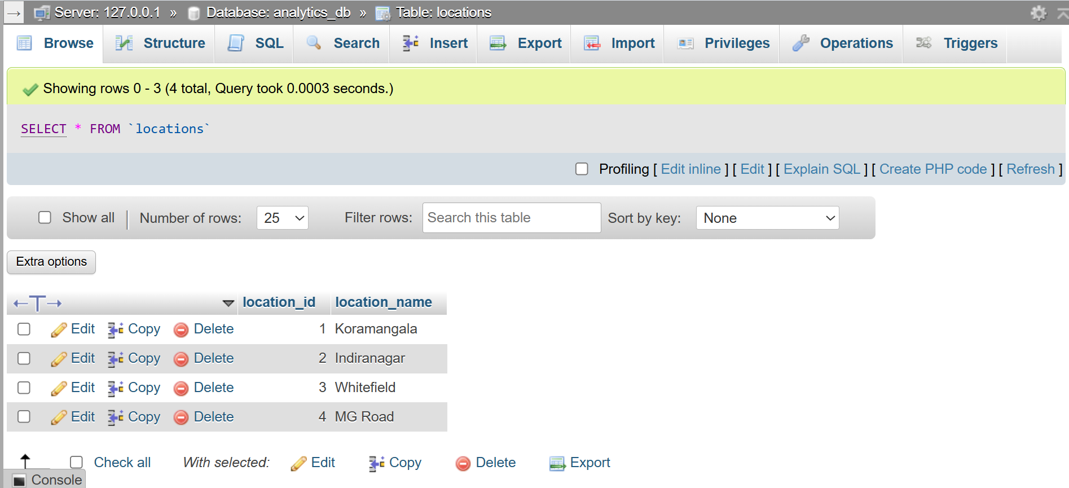
ALTER TABLE restaurants ADD location_id INT ;

UPDATE restaurants
SET location_id = 1
WHERE restaurant_id = 1;

UPDATE restaurants
SET location_id = 2
WHERE restaurant_id = 2;

UPDATE restaurants
SET location_id = 3
WHERE restaurant_id = 3;

UPDATE restaurants
SET location_id = 4
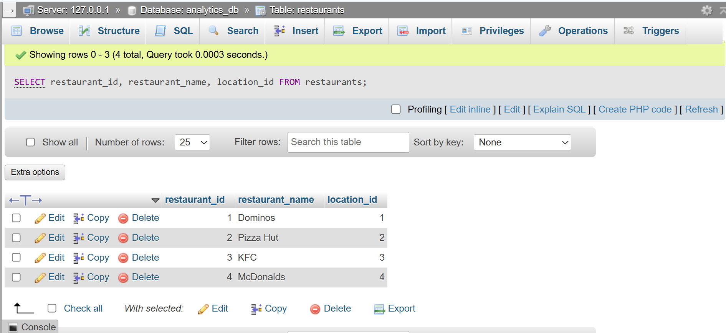
WHERE restaurant_id = 4;

ALTER TABLE restaurants
ADD CONSTRAINT fk_location
FOREIGN KEY (location_id) REFERENCES locations( location_id)
ON DELETE CASCADE;

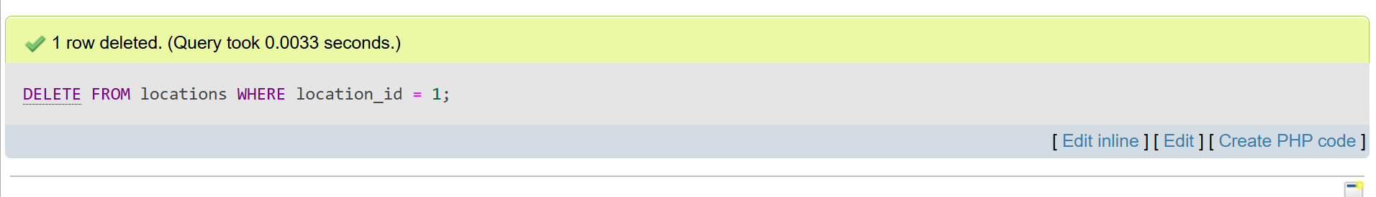
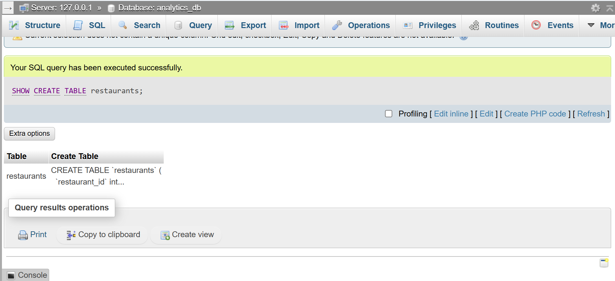
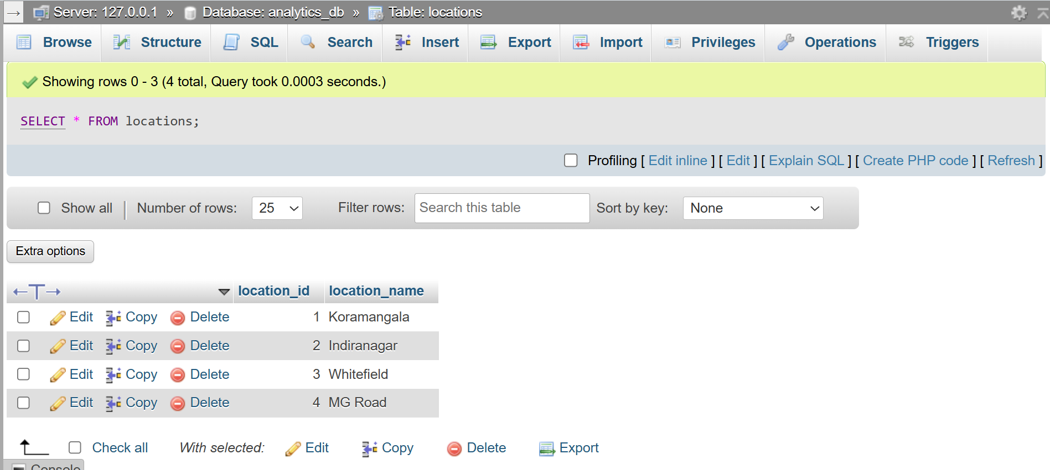
DELETE FROM locations WHERE location_id = 1;
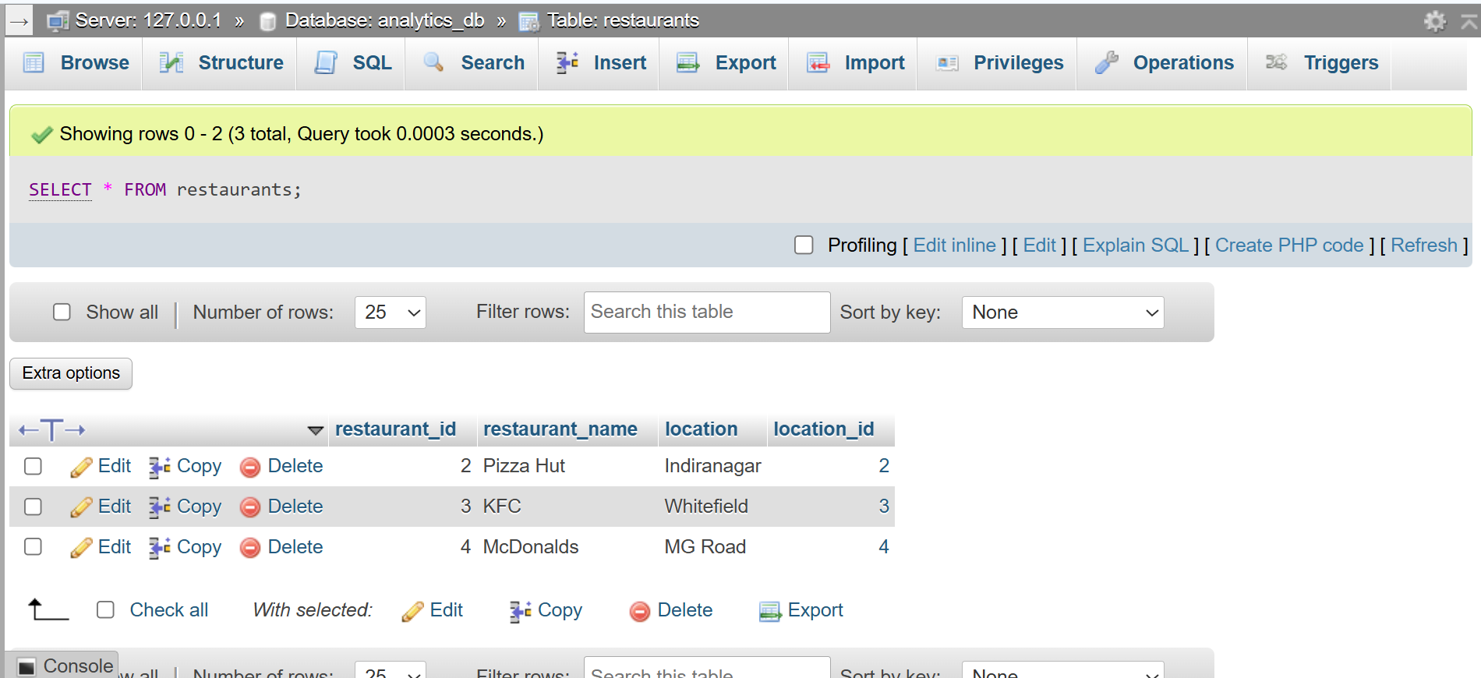
SELECT * FROM restaurants ;

Explanation :
“ The ALTER TABLE statement establishes a Foreign Key relationship between the restaurants and locations tables. The ON DELETE CASCADE action automatically deletes related records from the restaurants table when a referenced location is deleted. This maintains referential integrity and prevents orphan records ”

Python Validation Script using Pandas :
QUESTION : 3
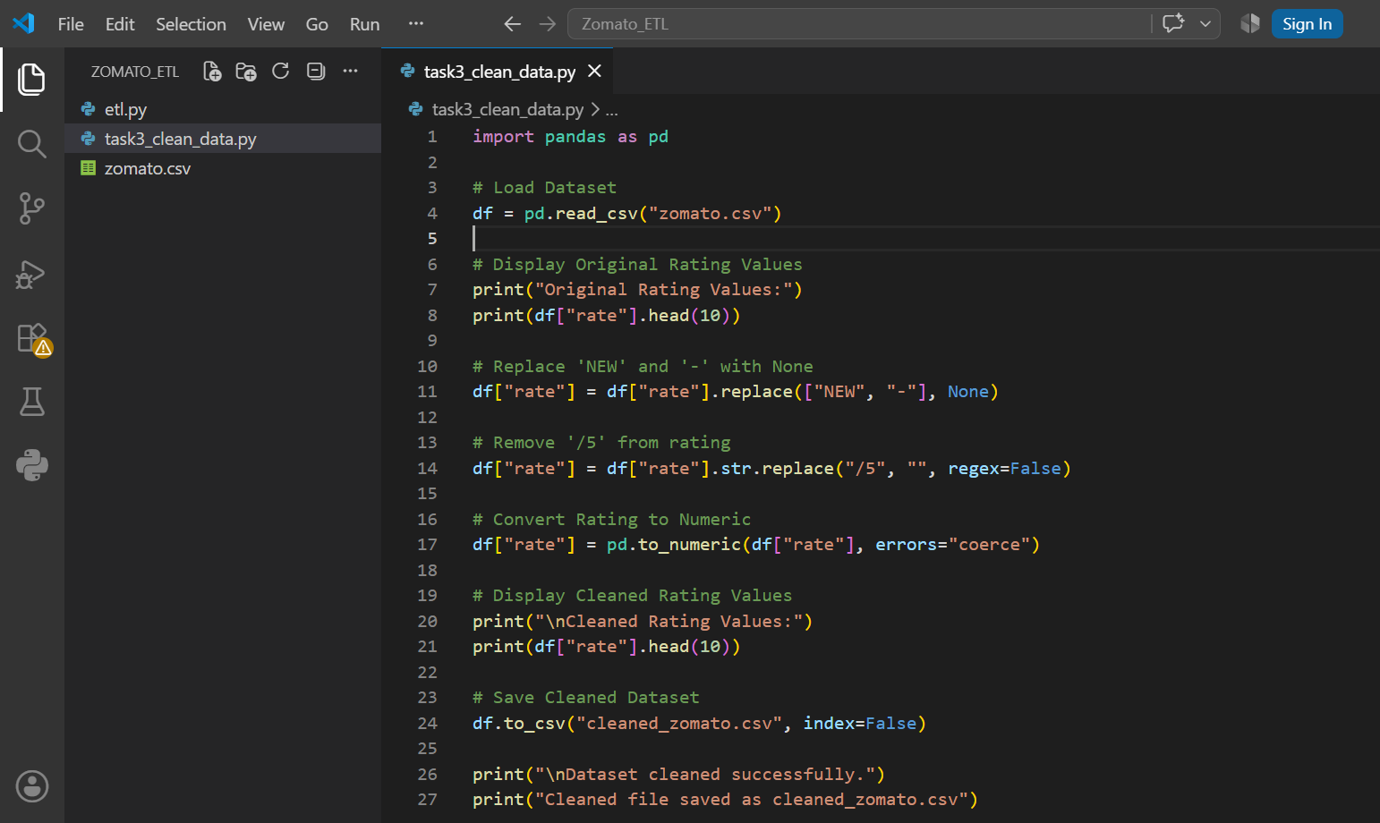
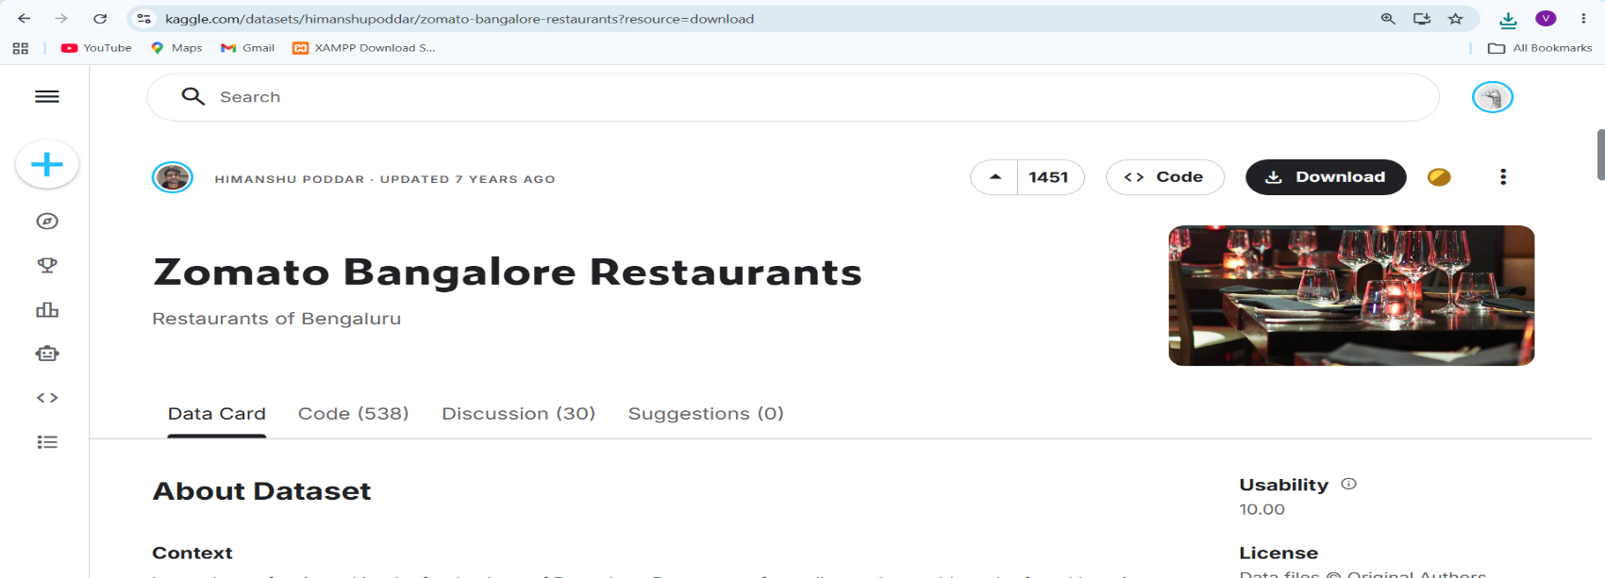
Write a Python validation script using Pandas to clean the Zomato dataset, handling "NEW" or "-" values in the rating column before relational ingestion :
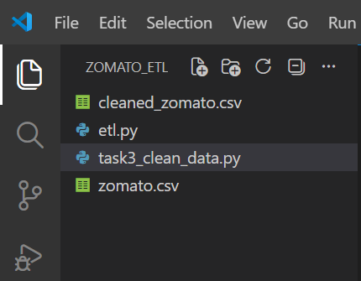
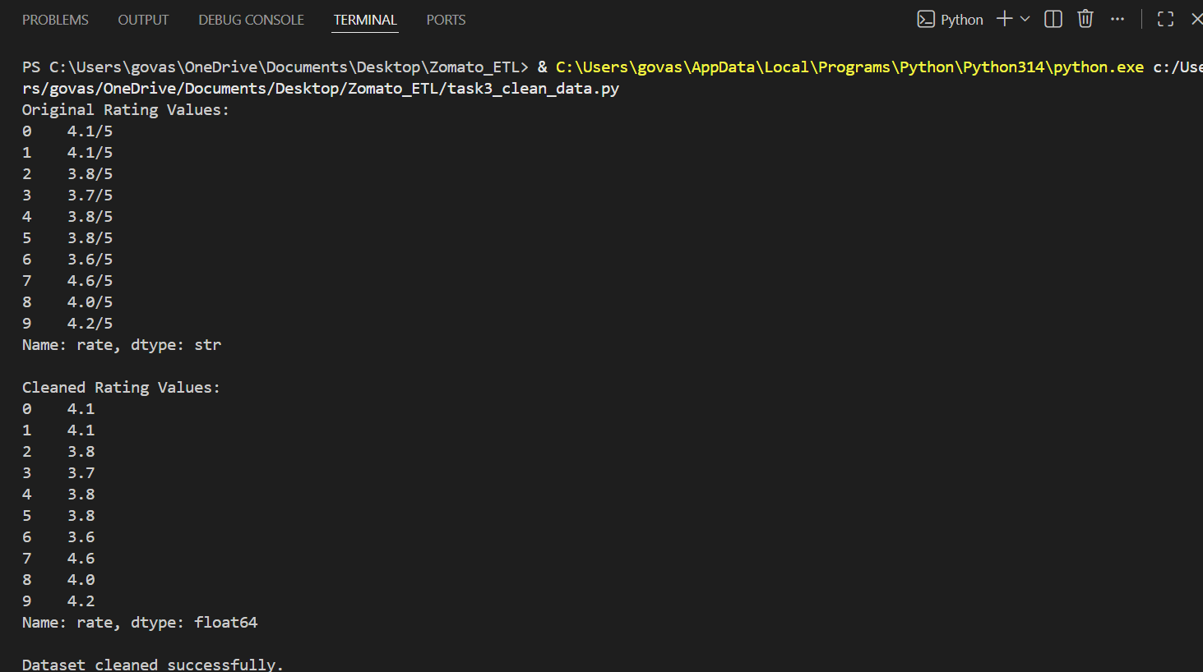

Explanation :
“ This Python script uses the Pandas library to clean the Zomato dataset before loading it into the relational database. It replaces "NEW" and "-" values with missing values (NaN), removes the /5 suffix from ratings, converts the ratings to numeric values, and saves the cleaned data into a new CSV file (cleaned_zomato.csv). This improves data quality before database ingestion ”
SQL Indexing Strategy :
QUESTION : 4
Construct an optimized SQL indexing strategy on the location_id and cuisines columns to accelerate multi-table JOIN operations for analytical queries :

ALTER TABLE restaurants ADD cuisines VARCHAR(100) ;
UPDATE restaurants
SET cuisines= CASE
WHEN restaurant_id= 2 THEN 'Italian'
WHEN restaurant_id= 3 THEN 'Fast Food'
WHEN restaurant_id= 4 THEN 'American'
END;
CREATE INDEX idx_location ON restaurants(location_id) ;
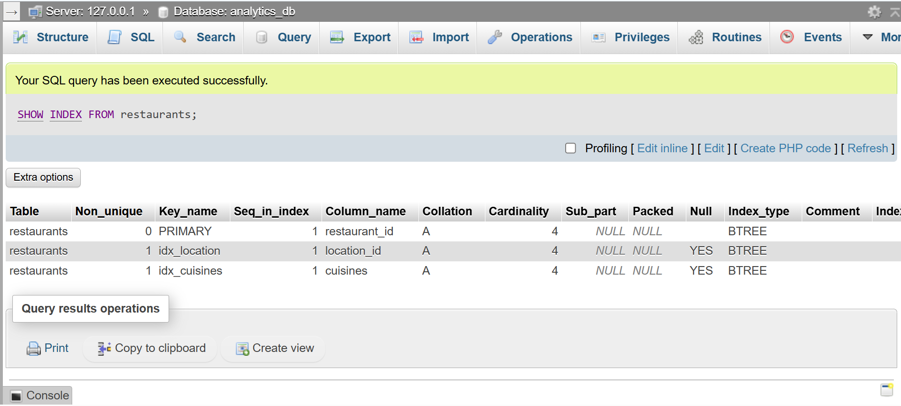
CREATE INDEX idx_cuisines ON restaurants(cuisines) ;
SELECT r.restaurant_name,l.location_name,r.cuisines
FROM restaurants as r
JOIN locations as l
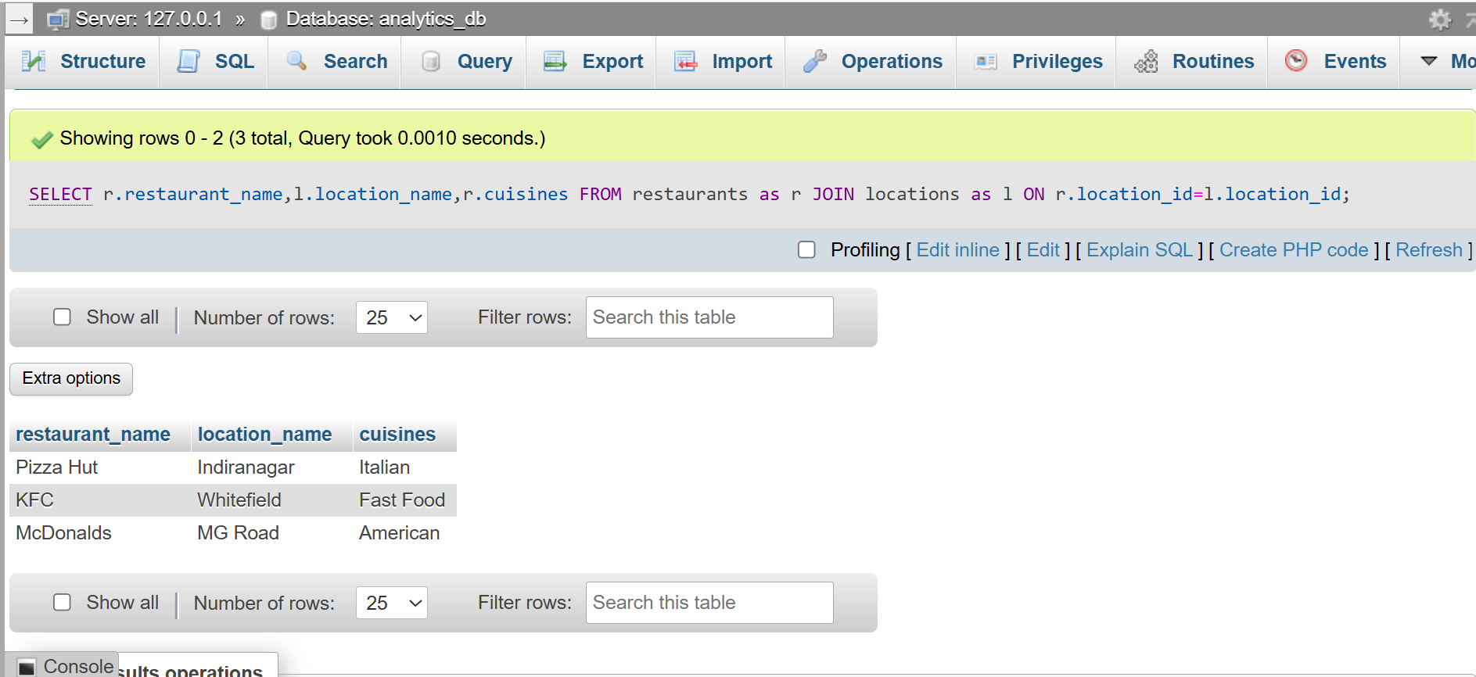
ON r.location_id=l.location_id ;
Explanation :
SQL indexes were created on the location_id and cuisines columns of the restaurants table to improve query performance. These indexes help the database locate matching records more efficiently during JOIN, WHERE, and filtering operations, reducing query execution time for analytical queries.

